Umina Rotary
is proud to present the Premiere Screening of
Umina – The First Fifty Years
A documentary by Julie Aitchison on the history of Umina 1914-1964
DATE 7th November 2015

TIME 6.30pm for 7pm

WHERE Cinema Paradiso
PRICE $15.00

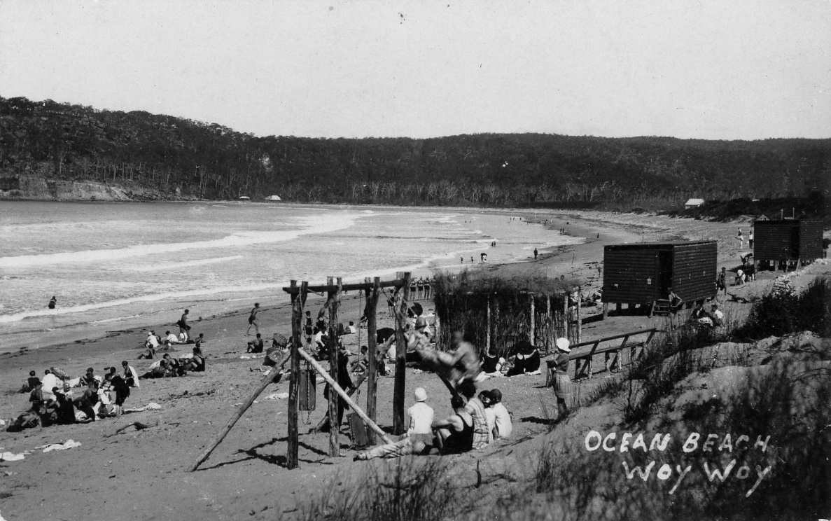
Pre Screening Drinks and Nibbles available.
All profits from ticket sales will be shared between Umina Rotary and Ocean Beach Surf Life Saving Club
2016 Calendars $15.00 and copies of DVD $20.00 also available

Enquiries Julie Aitchison: Email uminahistory@bigpond.com
Phone 0407 0702 48

